DAY-3

**Print the pattern**

**\***

**\* \***

**\* * \***

**\* * * \***

**\* * * * \***

n=int(input("enter the number of rows: "))  
for i in range(n+1,-1,-1):  
 for j in range(i+1,n+1):  
 print("*",end=" ")  
 print()

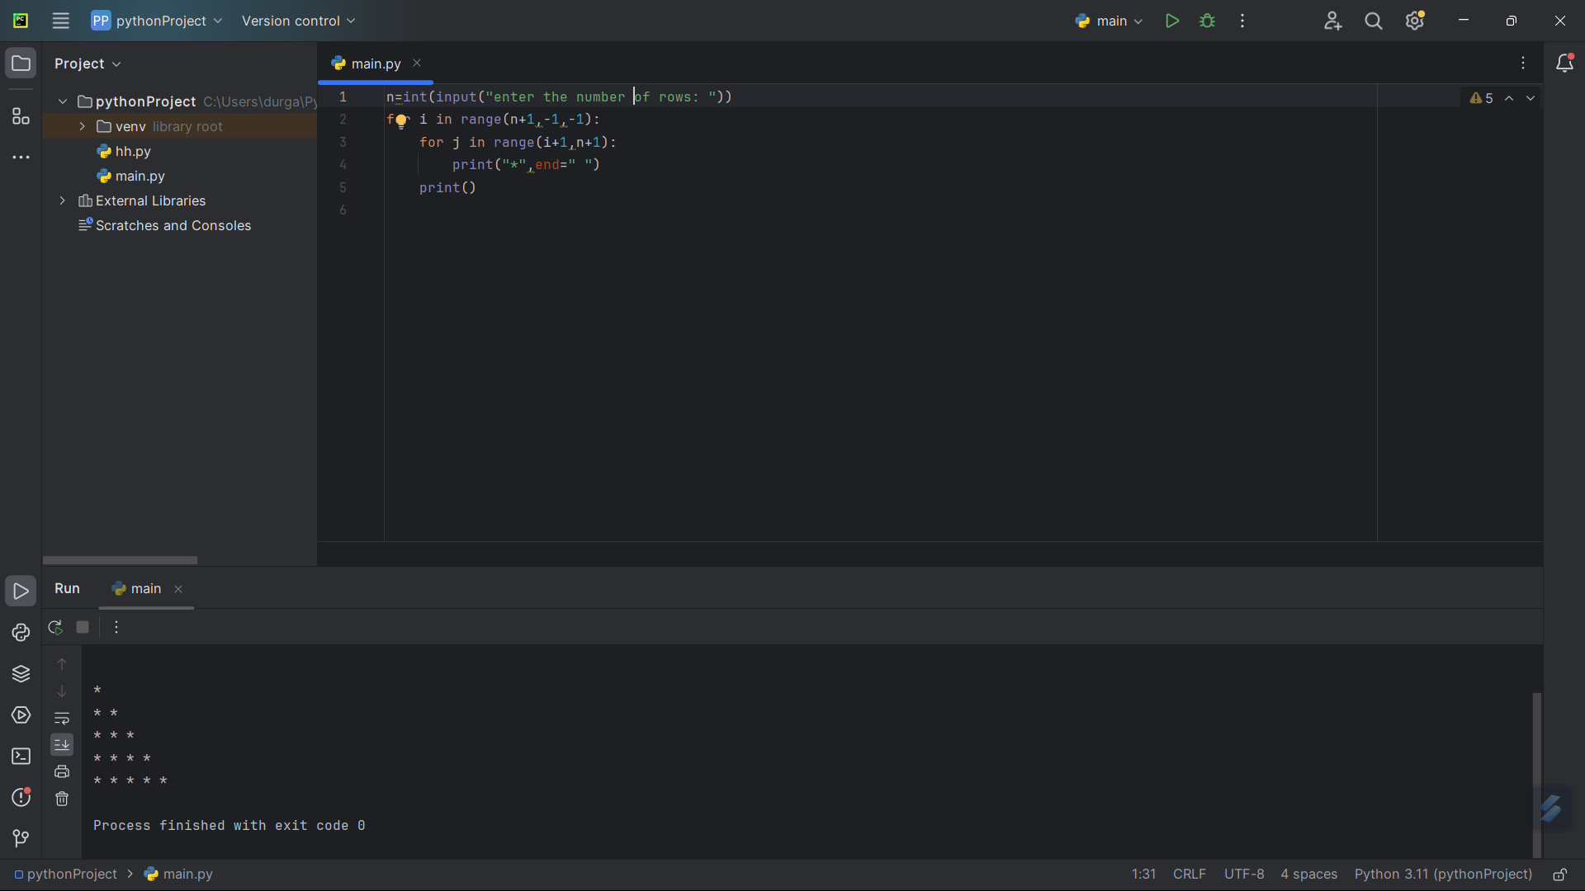

2. **Write a program to print the number of vowels and number of consonants in the given**

s=input("enter the string: ")  
v=["a","e","i","o","u"]  
countv=0  
countc=0  
for char in s:  
 if char in v:  
 countv+=1  
 if char not in v:  
 countc+=1  
print("number of vowels: ",countv)  
print("number of consonants: ",countc)

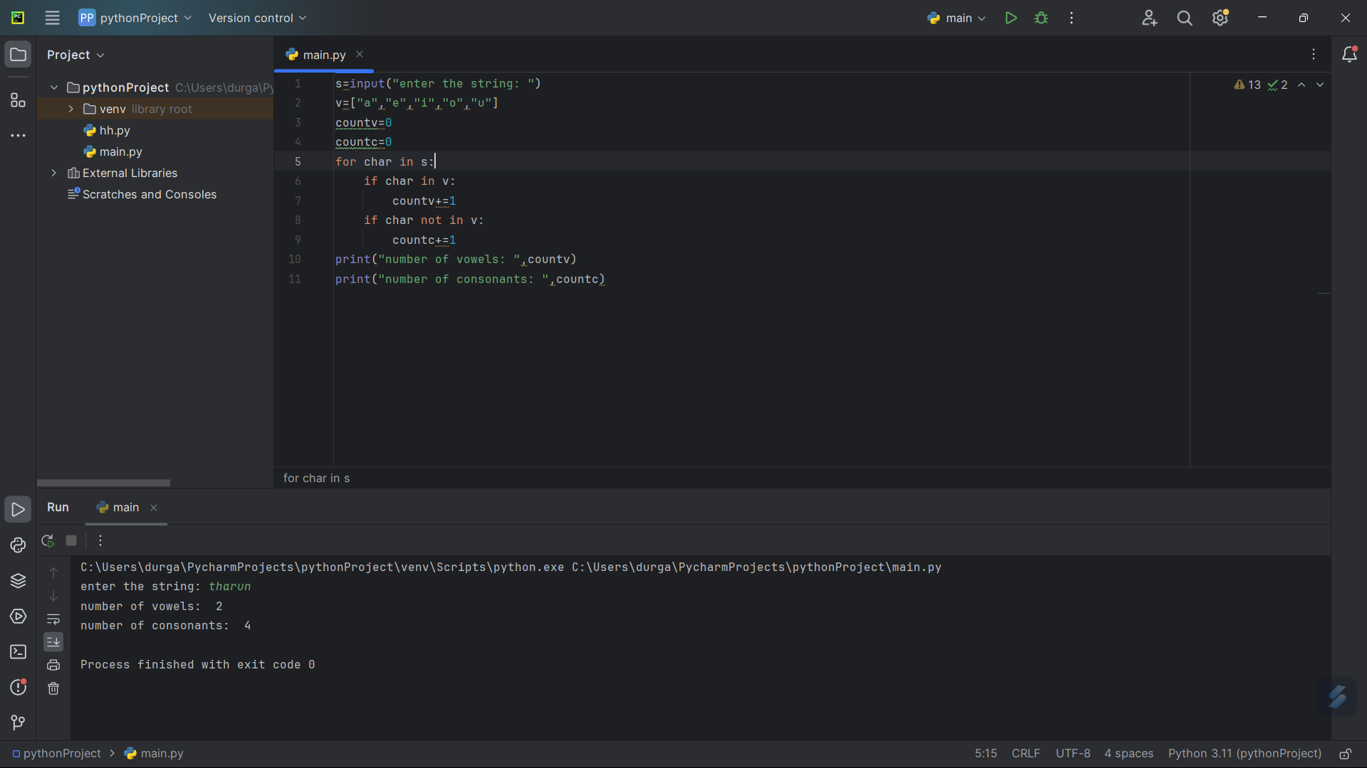

3. **Write a program to calculate Pow(x,n), Add(x,n), Sub(x,n), Mul(x,n), Div(x,n)? Get the input and choice from the user.**

a=int(input("enter the first number: "))  
b=int(input("enter the seconf number: "))  
c=input("enter the choice: \n1.pow\n2.add\n3.sub\n4.mul\n5.div\n")  
if c=='1':  
 print("power=",pow(a,b))  
elif c=='2':  
 print("sum=",a+b)  
elif c=='3':  
 print("difference=",a-b)  
elif c=='4':  
 print("multiplication=",a*b)  
elif c=='5':  
 print("division: ",a/b)  
else:  
 print("invalid operator")

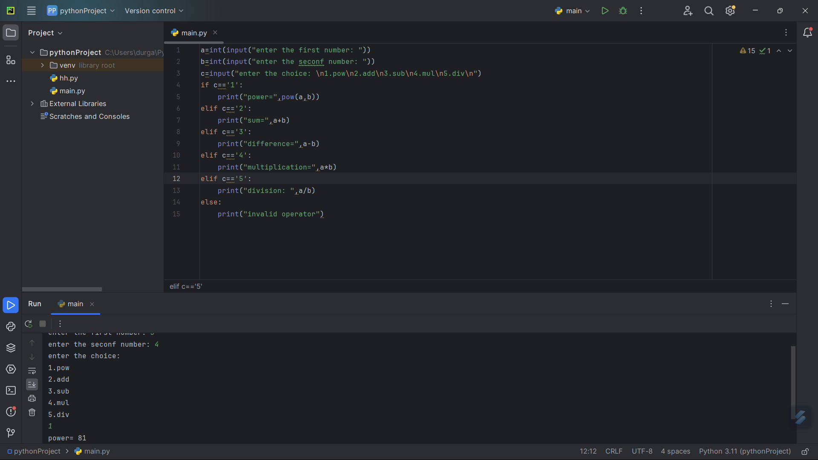

4. **Write a program to read the numbers until -1 is encountered. Find the average of positive numbers and negative numbers entered by user.**

nsum=0  
psum=0  
pcount=0  
ncount=0  
n=0  
while n!=-1:  
 n=int(input("enter the number: "))  
 if n>0:  
 psum+=n  
 pcount+=1  
 else:  
 nsum+=n  
 ncount+=1  
print("avernsum=0  
psum=0  
pcount=0  
ncount=0  
n=0  
while n!=-1:  
 n=int(input("enter the number: "))  
 if n>0:  
 psum+=n  
 pcount+=1  
 else:  
 nsum+=n  
 ncount+=1  
print("average of positive numbers: ",psum/pcount)  
print("average of negative numbers: ",nsum/ncount)

age of positive numbers: ",psum/pcount)  
print("average of negative numbers: ",nsum/ncount)

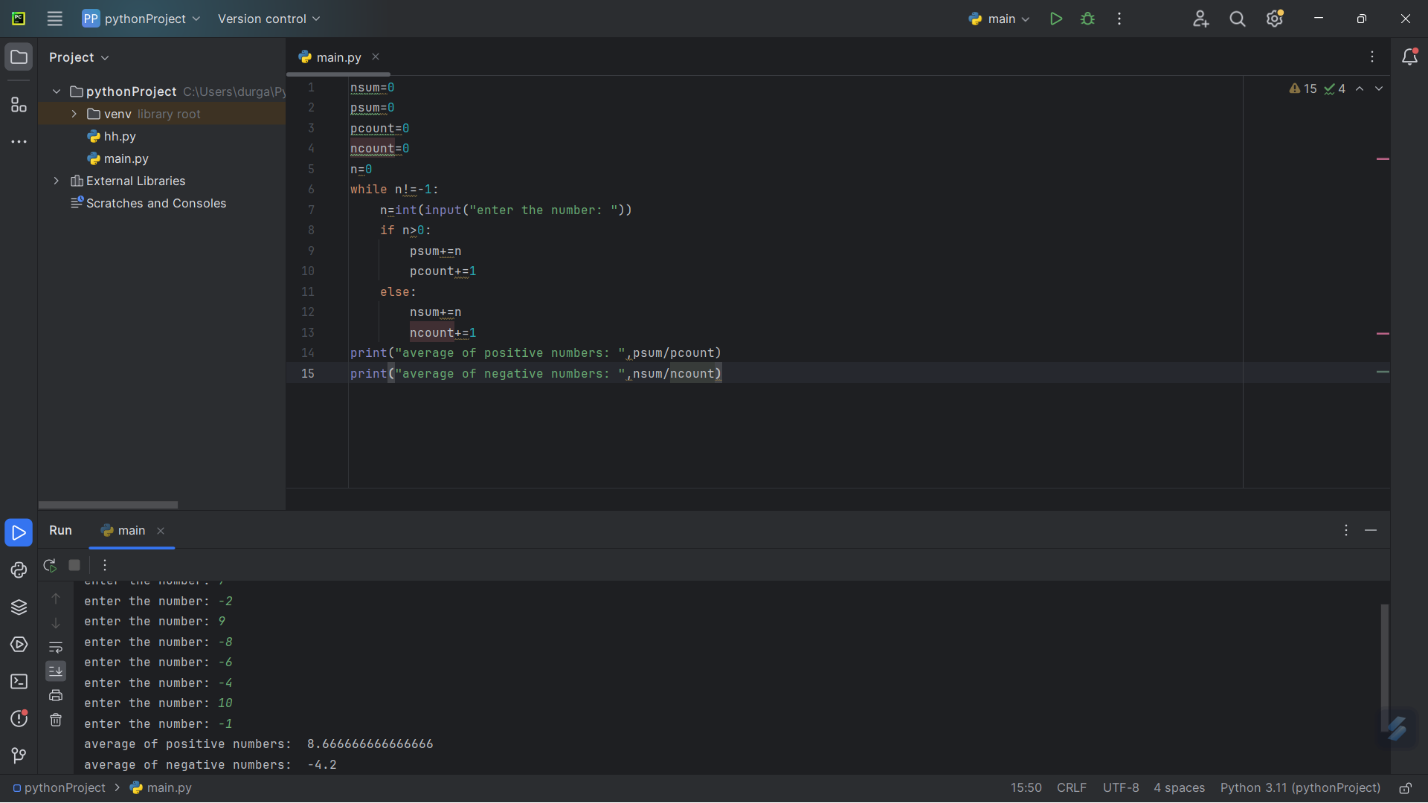

5. **Write a program to Reverse Words in a String**

str = input("Enter the string: ")  
words = str.split()  
reversed_words = ' '.join(words[::-1])  
print(reversed_words)

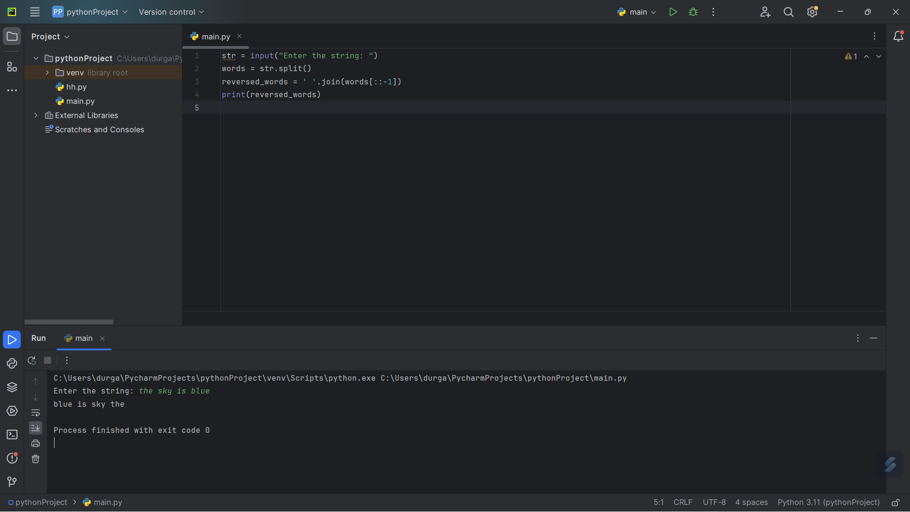

6. **Write a program to print the number of vowels and number of consonants in the given**

s=input("enter the string: ")  
v=["a","e","i","o","u"]  
countv=0  
countc=0  
for char in s:  
 if char in v:  
 countv+=1  
 if char not in v:  
 countc+=1  
print("number of vowels: ",countv)  
print("number of consonants: ",countc)



7. **Write a program to calculate tax given the following conditions:**

**If income is less than or equal to 1,50,000 then no tax**

**If taxable income is 1,50,001 – 3,00,000 the charge 10% tax**

**If taxable income is 3,00,001 – 5,00,000 the charge 20% tax**

**If taxable income is above 5,00,001 then charge 30% tax**

n=int(input("enter your income: "))  
if n<=150000:  
 tax=0  
elif n>150000 and n<=300000:  
 tax=0.1*n  
elif n>300000 and n<=500000:  
 tax=0.2*n  
else:  
 tax=0.3*n  
print("Tax to be payed: ",tax)

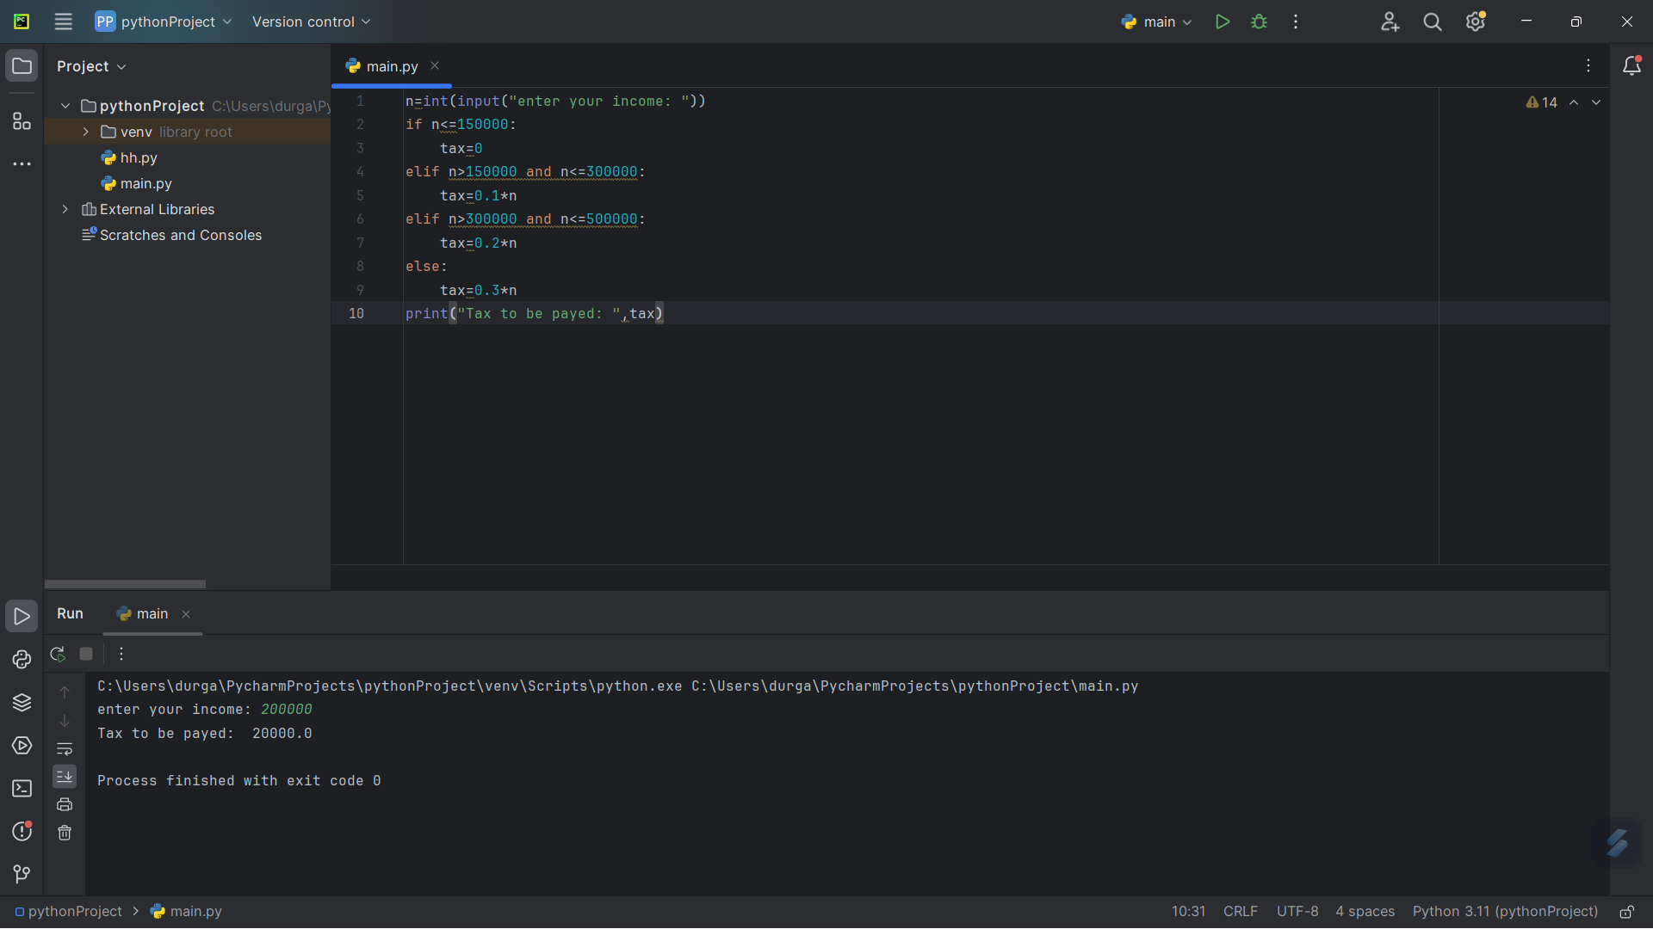

8. **Write a program to count number of spaces, line, vowels and consonants in a file**

**9. Print the pattern**

**0.1**

**0.1 0.2**

**0.1 0.2 0.3**

**0.1 0.2 0.3 0.4**

n=int(input("enter the number of rows: "))  
for i in range(1,n+1):  
 for j in range(1,i+1):  
 print((j*10)/100,end=" ")  
 print()

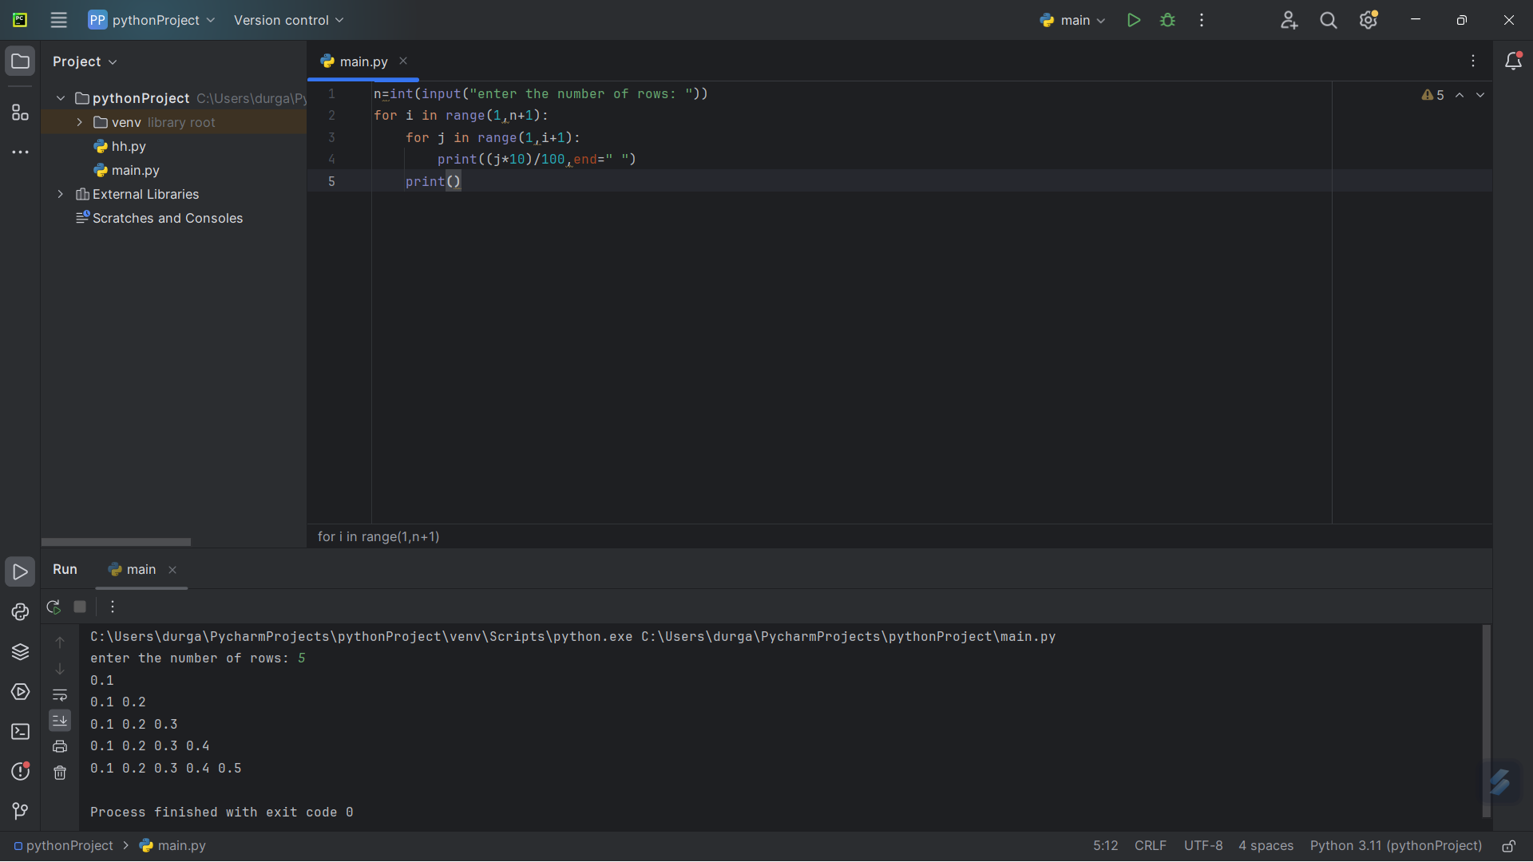

10. **Write a Program to find row, column and diagonal sum in Matrix**

r=int(input("enter the number of rows: "))  
c=int(input("enter the number of columns: "))  
row_sums = [0] * r  
col_sums = [0] * c  
diag_sum = 0  
matrix=[[0 for j in range(r)]for i in range(c)]  
for i in range(r):  
 for j in range(c):  
 matrix[i][j]=int(input())  
for i in range(r):  
 for j in range(c):  
 row_sums[i] += matrix[i][j]  
 col_sums[j] += matrix[i][j]  
 if i == j:  
 diag_sum += matrix[i][j]  
print("Row sums:", row_sums)  
print("Column sums:", col_sums)  
print("Diagonal sum:", diag_sum)

